How will America’s economy fare in 2024? Don’t ask a forecaster

2024美国经济将如何表现？别问预测者

## The consensus is that there is no consensus

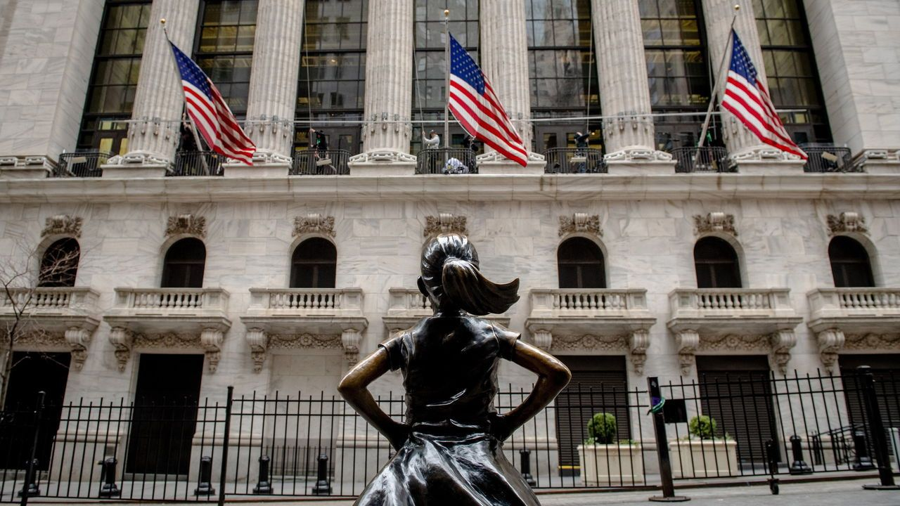

image: hilary swift/new york times/redux/eyevine

Nov 23rd 2023 | WASHINGTON, DC

November brings with it the beginning of the end of the year. The first frost signals winter has arrived. Thanksgiving marks the start of the holiday season. And from the hallowed halls of every large investment bank come pages and pages of “outlook” research. Their arrival means this year’s economic story is mostly written. Next year is what matters now.

11月带来了一年的尾声。第一场霜冻预示着冬天的到来。感恩节标志着假期的开始。而每个大型投资银行的神圣大厅里都会涌现出厚厚一叠的“展望”研究报告。它们的到来意味着今年的经济故事大体上已写好。现在最重要的是关注明年的情况。

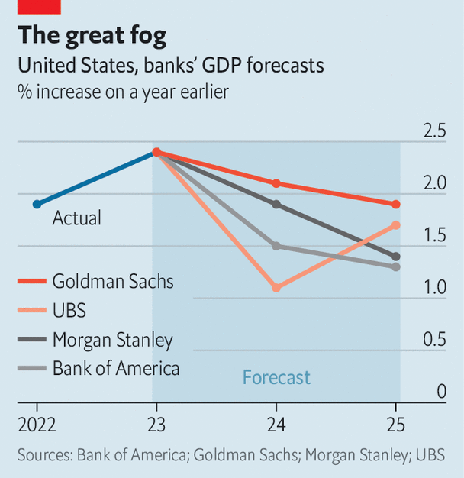image: the economist

Often an investor thumbing through all these will experience a sense of déjà vu. With all the vanity of small differences, researchers will elaborate on why their forecast for growth or inflation deviates by perhaps 30 or 40 hundredths of a percentage point from the “consensus” of their peers. (Your correspondent once penned such outlooks herself.)

投资者在阅读这些报告时，往往会感到一种似曾相识的感觉。研究人员们会带着寻找细微差异的虚荣心，详细阐述为什么他们对于经济增长或通胀的预测与同行的“共识”相比可能有3到4个百分点的差异，尽管这些差异并不重要。（您的通讯员自己也曾撰写过这样的展望报告。）

Yet this year’s crop did not deliver soporific sameness. Goldman Sachs expects growth in America to be robust, at 2.1%, around double the level that economists at ubs foresee. Some banks see inflation falling by half in 2024. Others think it will remain sticky, only dropping to around 3%, still well above the Federal Reserve’s target. Expectations for what the Fed will end up doing with interest rates range, accordingly, from basically nothing to 2.75 percentage points of rate cuts.

然而，今年的预测并没有呈现出令人昏昏欲睡的千篇一律。高盛预计美国的经济会以2.1%的比例迅猛增长，大约是瑞士银行经济学家预测水平的两倍。一些银行预计2024年的通胀率将下降一半。其他银行则认为通胀率将保持稳定，仅下降约3%，下降后的通胀率仍远高于美联储的目标。美联储最终将如何调整利率，预期范围从基本上无变化到降息2.75个百分点不等。

The differences between these scenarios come down to more than simple disagreement over growth prospects. Economists at Goldman might think growth and inflation will stay hot whereas those at ubs think both will slow down sharply. But Bank of America expects comparative stagflation, combining only a modest reduction in inflation with a pretty sharp drop in growth (and therefore little movement in the Fed’s policy rates). Morgan Stanley expects the opposite: a version of the “immaculate disinflation” world in which inflation can come back to target without growth dropping below trend much at all.

这些数据之间的差异不仅仅是关于增长前景的简单分歧。高盛的经济学家可能认为经济增长和通胀将保持火热状态，而瑞士银行的经济学家则认为二者将急剧放缓。然而，美国银行预计的是一种相对滞涨的情景，即通胀略有下降，而经济增长却大幅下滑（因此美联储的政策利率变动很小）。摩根士丹利则预计相反的情景：一种“完美无瑕的通缩”世界，其中通胀可以回归目标水平，而经济增长基本上不会低于趋势水平。

That each of the outcomes bank economists describe feels eminently plausible is a testament to the sheer level of uncertainty out there. Almost everyone has been surprised in turn by how hot inflation was, the speed of rate rises required to quell it and then the resilience of the economy. It is as if being repeatedly wrongfooted has given economic soothsayers more freedom: if nobody knows what will happen, you might as well say what you really think.

银行经济学家描述的每个结果都似乎非常可信，这证明了当前极高的不确定性水平。几乎每个人都被通胀的高涨、为控制通胀而需要迅速加息以及经济的抗压能力所惊讶。就像一次又一次打乱了脚步，反到给了经济预言家更多的自由：如果没有人知道会发生什么，那么你可以说出你真正的想法。

The result is a bewildering array of analogies. Economists at Deutsche Bank think the economy is heading back to the 1970s, with central bankers playing whack-a-mole with inflation. Those at ubs expect a “’90s redux”—a slowdown in growth as rates bite, followed by a boom as new technology drives productivity gains. Jan Hatzius of Goldman thinks comparisons with decades past are “too simple” and may lead investors astray.

结果是一系列令人困惑的类比。德意志银行的经济学家认为经济正在回到20世纪70年代，央行行使打地鼠的职能来应对通胀。瑞士银行的经济学家预计会出现“90年代复兴”，即随着利率上升，经济增长放缓，然后由新技术推动的生产率提升而引发经济繁荣。高盛的Jan Hatzius认为与过去几十年的比较“过于简单”，可能会误导投资者。

There is one similarity in the stories economists are telling, however. Many seem to think the worst is over. “The last mile” was the title of Morgan Stanley’s outlook document; “The hard part is over,” echoed Goldman. They might hope that this applies to both the economy and the difficulty of forecasting. In 2024 the contradictions in America’s economy should resolve themselves. Perhaps in 2025 there will be consensus once more.

然而，在经济学家们所讲述的故事中存在一个相似之处。许多人似乎认为最糟糕的时期已经过去了。摩根士丹利的展望文件标题为“最后一英里”；高盛则回应道“困难的部分已经过去”。他们可能希望这既适用于经济，也适用于预测的困难。在2024年，美国的经济矛盾应该得到解决。也许在2025年，将再次出现共识。